**Gaussian blur**

In image processing, a Gaussian blur (also known as Gaussian smoothing) is the result of blurring an image by a Gaussian Function. It is a widely used effect in graphics software, typically to reduce image noise and reduce detail. The visual effect of this blurring technique is a smooth blur resembling that of viewing the [image](https://en.wikipedia.org/wiki/Image) through a translucent screen, distinctly different from the bokeh effect produced by an out-of-focus lens or the shadow of an object under usual illumination. Gaussian smoothing is also used as a pre-processing stage in computer vision algorithms in order to enhance image structures at different scales.

Mathematically, applying a Gaussian blur to an image is the same as convolving the image with a Gaussian Function. By contrast, convolving by a circle (i.e., a circular [box blur](https://en.wikipedia.org/wiki/Box_blur)) would more accurately reproduce the [bokeh](https://en.wikipedia.org/wiki/Bokeh) effect. Since the [Fourier transform](https://en.wikipedia.org/wiki/Fourier_transform) of a Gaussian is another Gaussian, applying a Gaussian blur has the effect of reducing the image's high-frequency components; a Gaussian blur is thus a [low pass filter](https://en.wikipedia.org/wiki/Low_pass_filter).

The Gaussian blur is a type of image-blurring filter that uses a Gaussian function for calculating the transformation to apply to each pixel in the image. The equation of a Gaussian function in one dimension is

G(x)=12πσ2e−x22σ2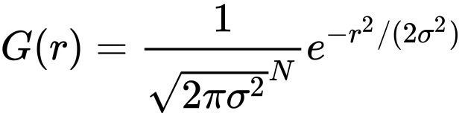

in two dimensions, it is the product of two such Gaussians, one in each dimension:

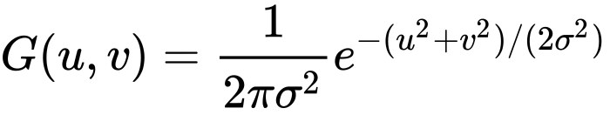





**Median blur**

The median filter is a nonlinear digital filtering technique, often used to remove noise from an image or signal. Such noise reduction is a typical pre-processing step to improve the results of later processing (for example, edge detection on an image). Median filtering is very widely used in digital image processing because, under certain conditions, it preserves edges while removing noise, also having applications in signal processing.

